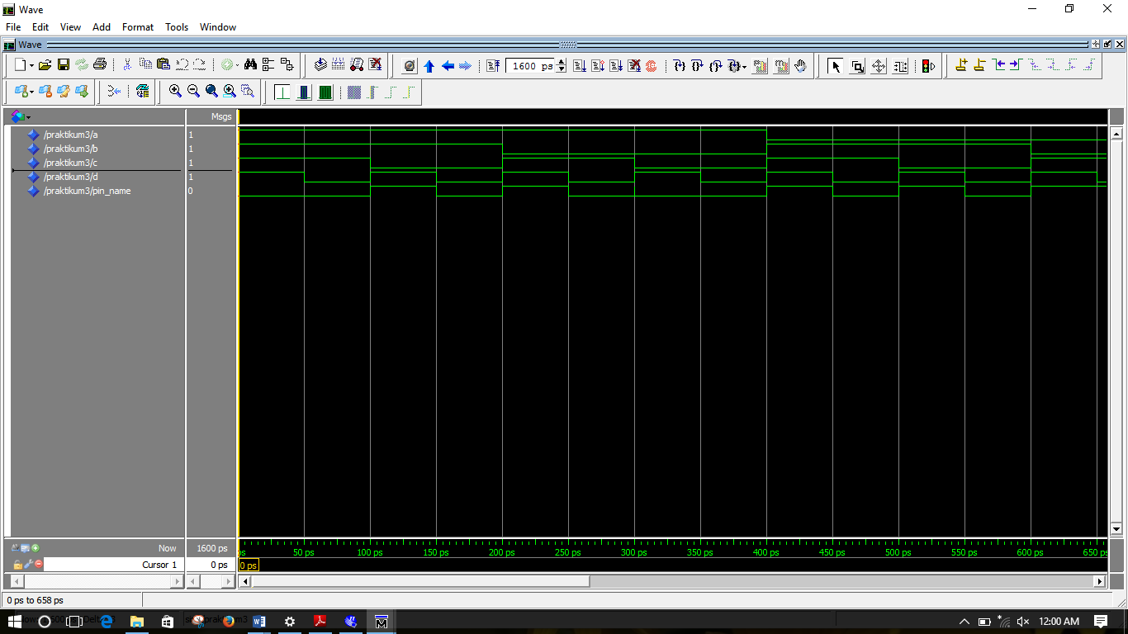

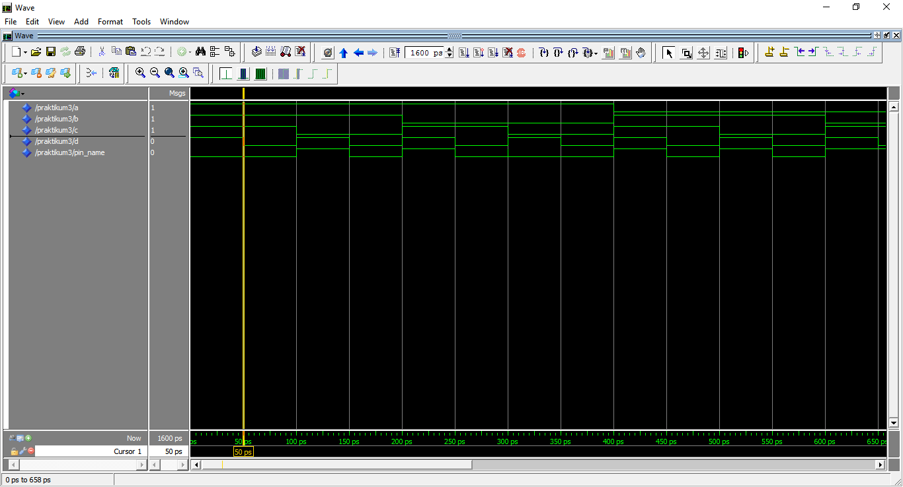

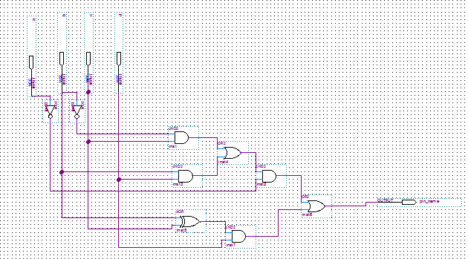

-- Copyright (C) 1991-2011 Altera Corporation

-- Your use of Altera Corporation's design tools, logic functions

-- and other software and tools, and its AMPP partner logic

-- functions, and any output files from any of the foregoing

-- (including device programming or simulation files), and any

-- associated documentation or information are expressly subject

-- to the terms and conditions of the Altera Program License

-- Subscription Agreement, Altera MegaCore Function License

-- Agreement, or other applicable license agreement, including,

-- without limitation, that your use is for the sole purpose of

-- programming logic devices manufactured by Altera and sold by

-- Altera or its authorized distributors. Please refer to the

-- applicable agreement for further details.

-- PROGRAM "Quartus II 64-Bit"

-- VERSION "Version 11.0 Build 157 04/27/2011 SJ Full Version"

-- CREATED "Fri Sep 15 23:41:13 2017"

LIBRARY ieee;

USE ieee.std_logic_1164.all;

LIBRARY work;

ENTITY praktikum3 IS

PORT

(

a : IN STD_LOGIC;

b : IN STD_LOGIC;

c : IN STD_LOGIC;

d : IN STD_LOGIC;

pin_name : OUT STD_LOGIC

);

END praktikum3;

ARCHITECTURE bdf_type OF praktikum3 IS

SIGNAL SYNTHESIZED_WIRE_0 : STD_LOGIC;

SIGNAL SYNTHESIZED_WIRE_1 : STD_LOGIC;

SIGNAL SYNTHESIZED_WIRE_2 : STD_LOGIC;

SIGNAL SYNTHESIZED_WIRE_3 : STD_LOGIC;

SIGNAL SYNTHESIZED_WIRE_4 : STD_LOGIC;

SIGNAL SYNTHESIZED_WIRE_5 : STD_LOGIC;

SIGNAL SYNTHESIZED_WIRE_6 : STD_LOGIC;

SIGNAL SYNTHESIZED_WIRE_7 : STD_LOGIC;

BEGIN

SYNTHESIZED_WIRE_4 <= SYNTHESIZED_WIRE_0 AND c;

SYNTHESIZED_WIRE_6 <= SYNTHESIZED_WIRE_1 AND SYNTHESIZED_WIRE_2;

SYNTHESIZED_WIRE_3 <= b AND d;

SYNTHESIZED_WIRE_1 <= SYNTHESIZED_WIRE_3 OR SYNTHESIZED_WIRE_4;

SYNTHESIZED_WIRE_7 <= b XOR c;

pin_name <= SYNTHESIZED_WIRE_5 OR SYNTHESIZED_WIRE_6;

SYNTHESIZED_WIRE_5 <= SYNTHESIZED_WIRE_7 AND d;

SYNTHESIZED_WIRE_2 <= NOT(a);

SYNTHESIZED_WIRE_0 <= NOT(b);

END bdf_type;